Keel Survey 2008
Fig 3

GRAPHICS SHEET 1
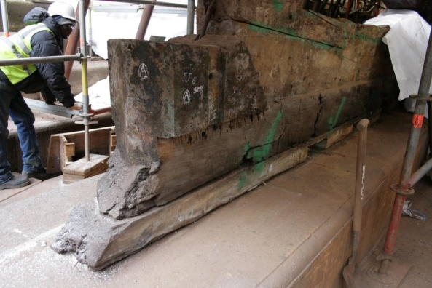
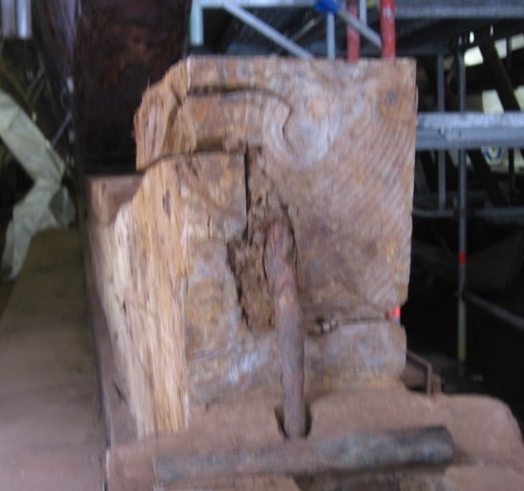
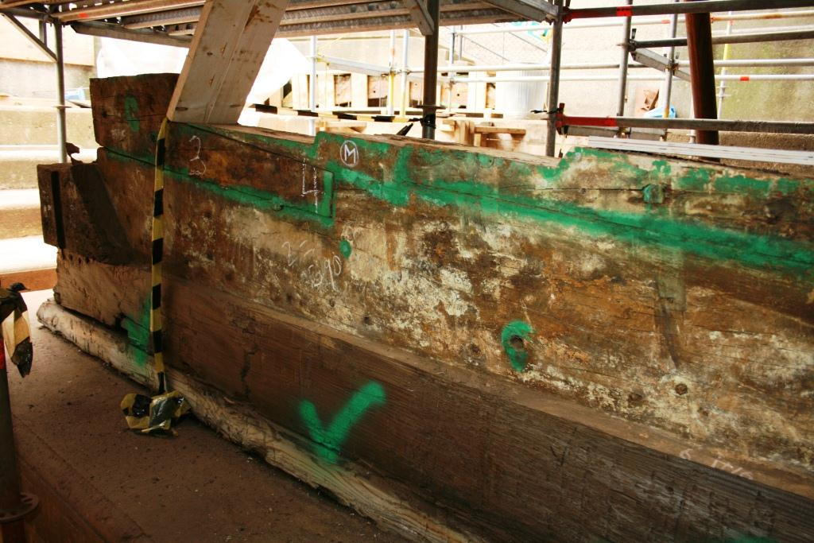
Q
R
Q
Fig 2
Fig 1
Q
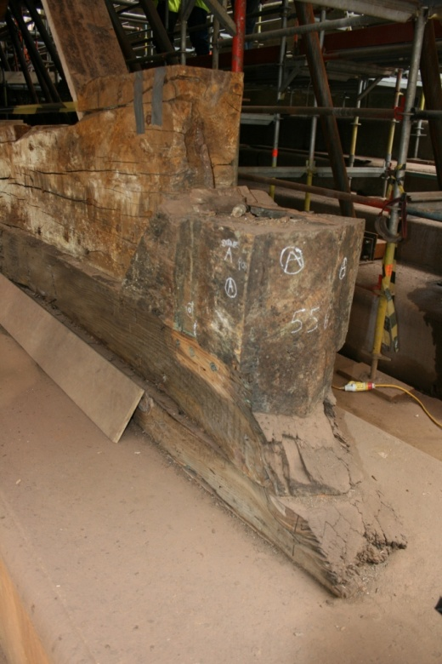
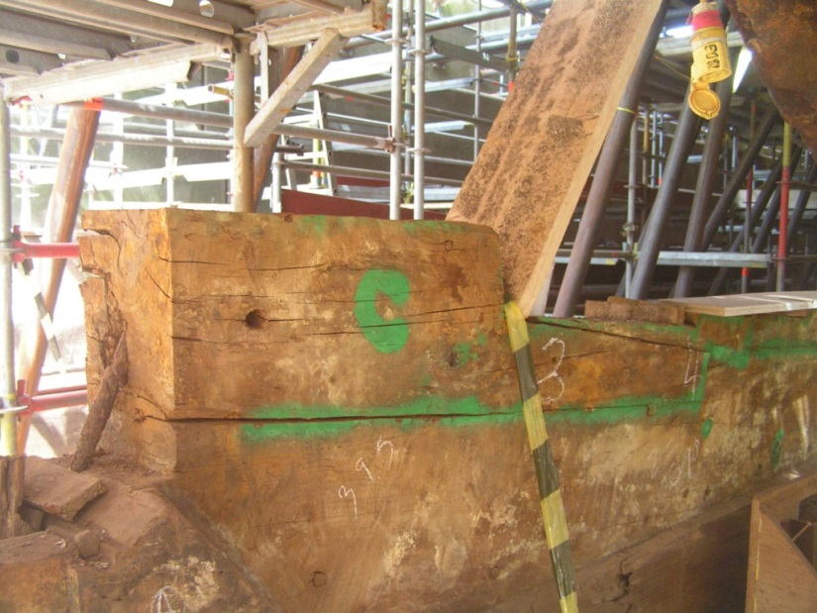
Mortise for sternpost
False keel

False keel

Q
Fig 4
Fig 5
Q

