Keel Survey 2008

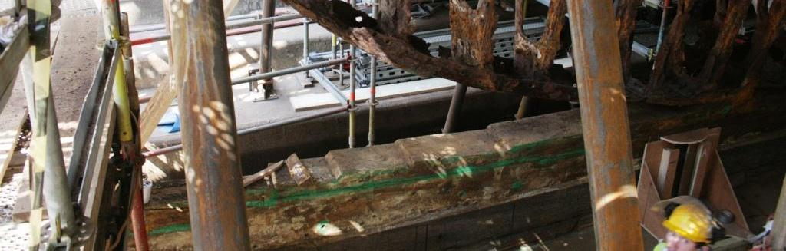
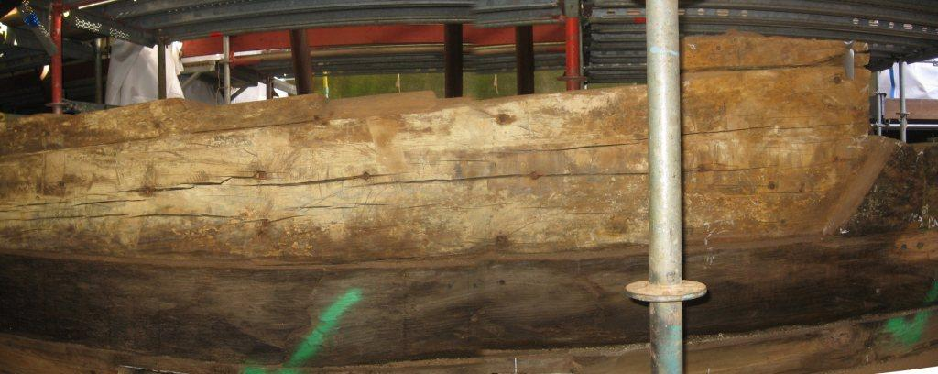
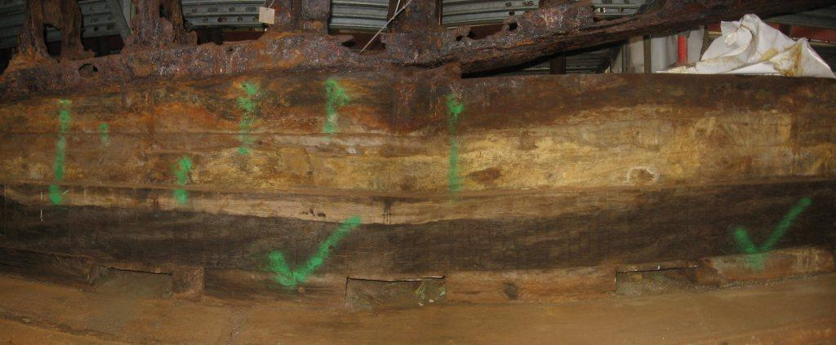
Graphics sheet 2
Q
11
Fig 8. Note notches for deadwood on ‘R’
R
Fig 7. Evidence of ‘Q’ top right port
Fig 6. Where rib 11 meets keel

