Keel Survey 2008

GRAPHICS SHEET 3

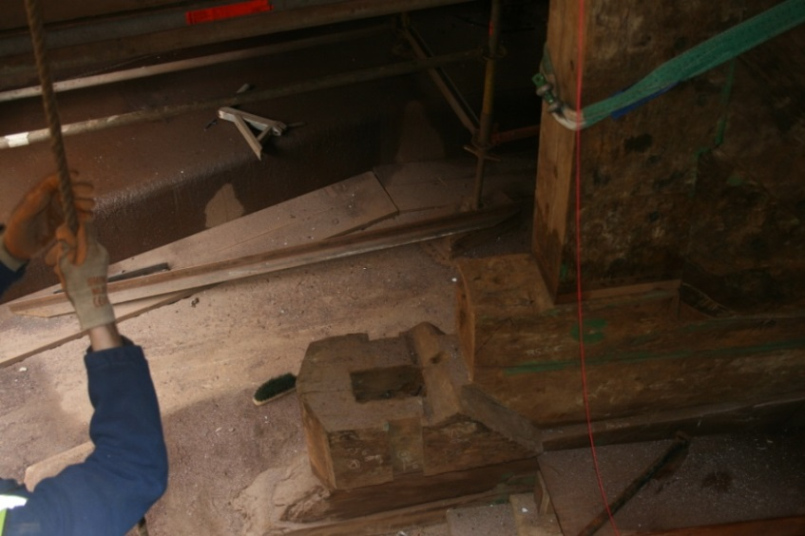
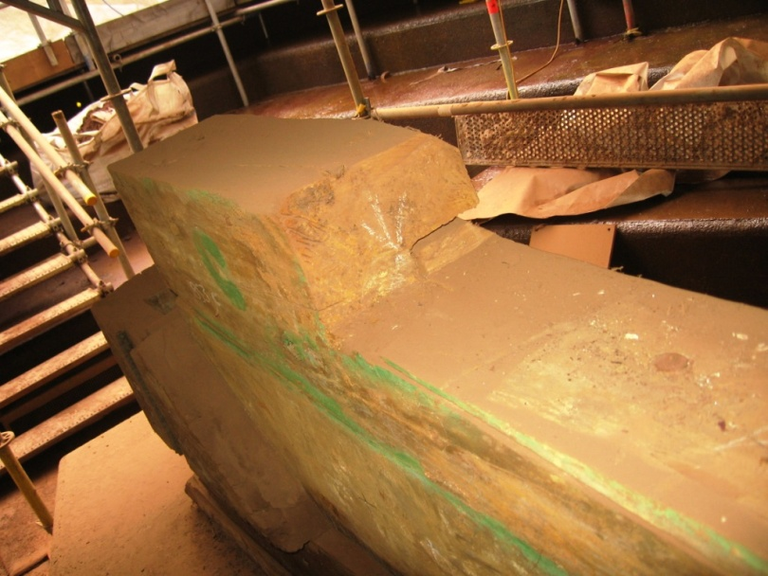
Mortise to receive tenon on sternpost
Note joint line of ‘Q’ insert

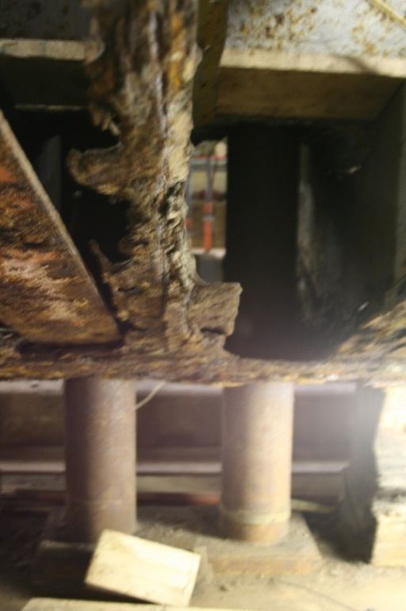
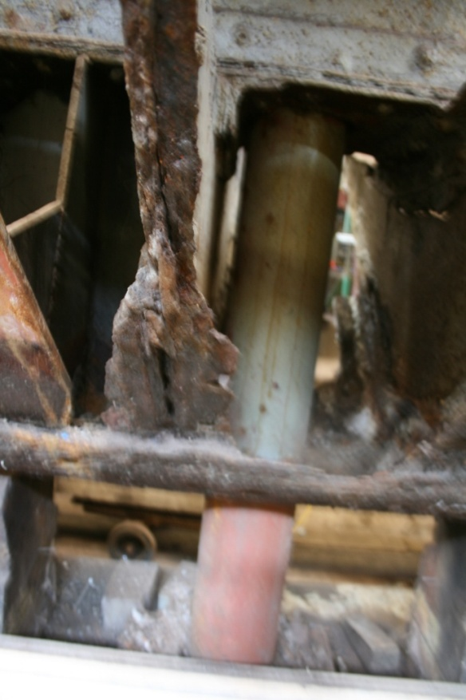
Fig 10 - Stools supporting main mast weight.
Fig 11- Stool supporting fore mast weight
Fig 9
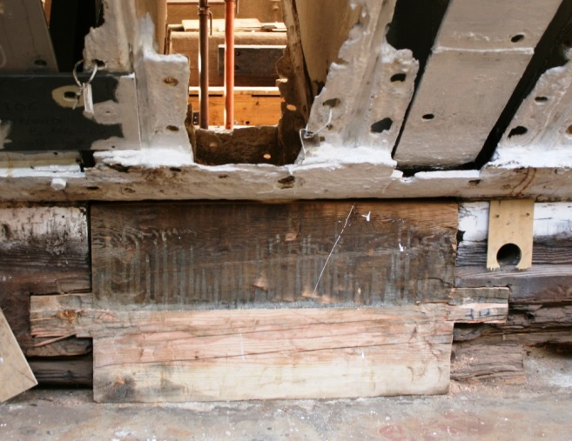
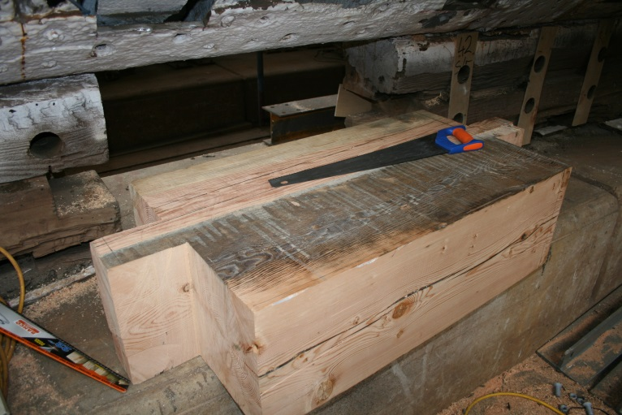
Filler in keel below fore mast
Q

